**PROJECT : INVESTMENT BANKING**

Project Name : Investment Banking ( Customer Onboarding Module)

Author : Developer Guide

Date Of Assignment: 01-11-2021

Date Of Submission: 01-11-2021

Document detail

|  |  |  |  |  |
| --- | --- | --- | --- | --- |
| Name | Description | Version | Comment | Date |
| Developer Guide | Initial Draft | 1.0 |  | 01-11-2021 |
|  |  |  |  |  |

Document Future Scope

|  |
| --- |
|  |
|  |
|  |
|  |
|  |

**Course Content**

* Requirement Gathering
* Project life-cycle discussion
* Agile Methodology discussion
* Jira Setup and management
* Confluence setup
* Git Setup and Management (Git Repository)
* Jenkin Pipeline
* Create RAML and best practice
* Develop API and best practice
* Testing (Unit Testing/ Integration Testing / Munit Testing / Performance testing)
* Code Check-in and CI-CD
* Discussion about deployment modal ( On-Premise, Cloud-Hud, RTF, Hybrid )
* DEV and PROD Environment Setup ( DEV -> SIT -> UAT -> PrePROD ->PROD )
* Deploy application on Cloud-hub
* Environment promotion (DEV->PROD)
* Apply policy and security
* How to explain project in interview

|  |  |  |
| --- | --- | --- |
| **Connector** | **component** | **Policy** |
| Salesforce | Scatter-Gather | Client enforcement |
| DB | Batch Processing | Rate limiting |
| VM/JMS | Parallel for each | Spike control |
| HTTP | Caching | HTTP Caching |
| Object store | Choice router | Basic Auth |
| Custom connector for logger | Error handling | JWT |
| Socket | For each |  |

**Objective of this exercise**

* To simulate a real-world scenario, where a solution architecture document will be handed down to the development team to build & implement.
* Make use of MuleSoft out of the box capabilities (as much as possible) to come out with a solution to address the design problems addressed in the use case.
* Include previous best practices experience when coming out with the solution.
* Make use of Design Center to create RAML projects and design RAML specification base RAML best practices based on the business scenario given.
* Organize and create the mule projects based on the business scenarios, and solutions described in this document.
* Creating mule message flows, making use of mule components and connectors. implement a solution based on the scenario and specifications given in this document.
* M-unit test is created to test each of the possible scenarios.
* Test scripts creation to test the end point using testing tools such as Postman / Soap UI (if needed) and JMeter.
* Demo the working example at the end. During the presentation, outline in detail what you are trying to solve in your Mule project and the approach to resolve it.
* Extend and enhance your application in real-time.

Business Scenario

Investment banking Customer onboarding system will allow customers create account , to check and update the member details ,member login and reset member credentials. First customer will go to company portal and using signup option will create account by providing basic details. Once customers complete successful member registration, they can login using the login username and password details. If in case, customers forget the login details, they can utilize forgot password and forgot username options.

During customers login, they will receive an OTP on their mobile which is needed as part of login process. After successful login, customer can view member details, update member details, reset password.

Flow Diagram

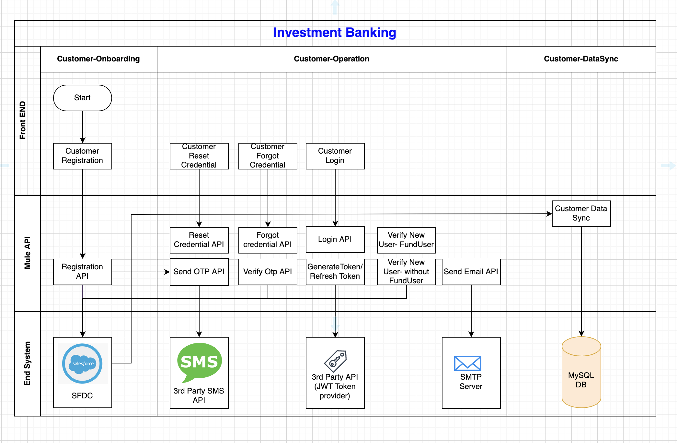

# 

# API Landscape

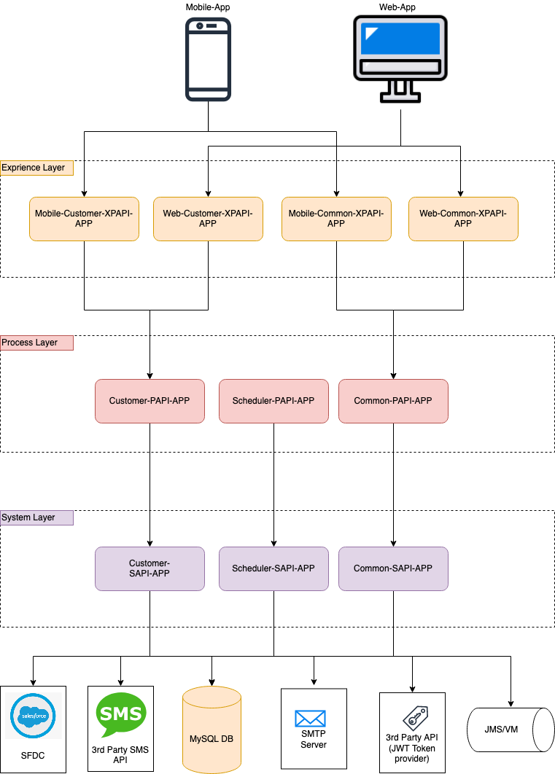

# Mobile-Customer-XPAPI-APP

* 1. customer-registration-xpapi
  2. customer-login-xpapi
  3. customer-reset-credential-xpapi
  4. customer-forgot-credential-xpapi
  5. customer-verify-fundUser-xpapi
  6. customer-verify-nonFunduser-xpapi

# Web-Customer-XPAPI-APP

* 1. customer-registration-xpapi
  2. customer-login-xpapi
  3. customer-reset-credential-xpapi
  4. customer-forgot-credential-xpapi
  5. customer-verify-fundUser-xpapi
  6. customer-verify-nonFunduser-xpapi

# Mobile-Common-XPAPI-APP

* 1. common-send-email-xpapi
  2. common-msg-email-xpapi
  3. common-verify-otp-xpapi
  4. common-generate-token-xpapi
  5. common-refresh-token-xpapi

# Web-Common-XPAPI-APP

* 1. common-send-email-xpapi
  2. common-msg-email-xpapi
  3. common-verify-otp-xpapi
  4. common-generate-token-xpapi
  5. common-refresh-token-xpapi

# Customer-PAPI-APP

* 1. customer-registration-papi
  2. customer-login-papi
  3. customer-reset-credential-papi
  4. customer-forgot-credential-papi
  5. customer-verify-fundUser-papi
  6. customer-verify-nonFunduser-papi

# Common-PAPI-APP

* 1. common-send-email-papi
  2. common-msg-email-papi
  3. common-verify-otp-papi
  4. common-generate-token-papi
  5. common-refresh-token-papi

# Scheduler-PAPI-APP

* 1. Customer-data-sync-papi

# Customer-SAPI-APP

* 1. customer-registration-sapi
  2. customer-login-sapi
  3. customer-reset-credential-sapi
  4. customer-forgot-credential-sapi
  5. customer-verify-fundUser-sapi
  6. customer-verify-nonFunduser-sapi

# Common-SAPI-APP

* 1. common-send-email-sapi
  2. common-send-msg-sapi
  3. common-verify-otp-sapi
  4. common-generate-token-sapi
  5. common-refresh-token-sapi

# Common-SAPI-APP

* 1. Customer-data-sync-sapi

**External System:**

1. **Salesforce**

Salesforce is a cloud computing service as a software (SaaS) company that specialises in customer relationship management (CRM). Salesforce's services allow businesses to use cloud technology to better connect with customers, partners and potential customers. The software has become the number one for customer success and helps businesses track customer activity, market to customers and many more services.

1. **Data Base**

A database is a collection of information that is organised so that it can be easily accessed, managed and updated. Computer databases typically contain aggregations of data records or files, containing information about sales transactions or interactions with specific customers.

1. **Object Store**

Often referred to as object-based storage, is a data storage architecture for handling large amounts of unstructured data. This is data that does not transform to or cannot be organised easily into a traditional relational database with rows and columns.

1. **External SMS and EMAIL API**

These 3rd party API will use to send email and SMS.

1. **FrontEnd**

It is the website with which user interacts. It is also known as user interface.

BATCH DETAILS

Organised By Developer Guide:

Investment Banking Real-time Project Live Session

Start Date : 20 Nov 2021

Introduction session

RealTime Project Training Session (Weekend Session):

SaturDay : 7:30 PM IST to 10:30 PM IST

SunDay : 7:30 PM IST to 10:30 PM IST

Doubt Session:

Two time in a week and will be decided on Adhoc basis.

For Registration

Contact : WhatsApp : +91 7411764131

10 API Development in class and 30 API development as assignment.

Here will we cover and complete registration process.

Fee : RS 14000,Training session Duration 1 month and Doubt session duration 15 Days.

Total training class : 10 ( 3 Hour each )

Total doubt session : 12 + 15 ( 2 Hour each )

Organised By Developer Guide:

Demo Link : <https://www.youtube.com/watch?v=J6Svgt_rMn8>

Demo Previous Project

Transport Module: <https://www.youtube.com/watch?v=zZUtdFsLcIk&list=PL2LUDEomJp_hyALpjtwK2AI1rGs9G6u-J>

Loyalty Module): <https://www.youtube.com/watch?v=I7pLyepUlOs&list=PL2LUDEomJp_jjF9KMjk_4jQtosrvToptw>

For Registration

Contact : WhatsApp Chat : +91 7411764131